GrandLord System

SOFT7009 - Software Project

CIT 2015

**Lecturer: Simon Long**

**Students: Adam Napora**

**Piotr Baran**

**Grzegorz Jokiel**

# Content

### Project Drivers

1. The Purpose of the Project.
2. The Stakeholders
3. Problem description

### Project Constraints

1. Mandated Constraints
2. Naming Conventions and Definitions
3. Relevant Facts and Assumptions

### Functional Requirements

1. The Scope of the Work
2. Business Data Model
3. The Scope of the Product
4. Functional Requirements

### Non-functional Requirements

1. Look and Feel Requirements
2. Usability Requirements
3. Performance Requirements
4. Operational and Environmental Requirements
5. Security Requirements
6. Legal Requirements

# 1. The Purpose of the Project

Enable tenants and any interested parties to view opinions on properties, landlords and agencies looking after properties for rent. Make interest from 3rd party integration, users donations and advertisements.

# 2. Problem description

At the time of writing this report there is no website or system that enable tenants to check reviews on properties, landlords and agencies that offer accommodation to rent in Ireland. Many tenants would like to see other tenants opinions about landlord or agency advertising accommodation to rent. Lack of information about landlords and properties causes unnecessary risk and uncertainty before committing to live in certain place for the time specified in a lease contract. In order to enable tenants to check reviews on properties there is a system required that will gather all required information for future reference of other users. We believe that GrandLord System will enable all interested parties to seek required information about properties and owners helping everyone to meet their expectations.

# 3. The Stakeholders

**3a. The Owners**

* Adam Napora
* Piotr Baran
* GrzegorzJokiel

**3b. The Customers**

* unregistered users
* registered tenants
* registered landlords
* registered property agencies
* third party companies

**3c. Other Stakeholders**

* website moderator (staff)
* third party systems (payment system)
* developers
* system administrator (support)

# 4. Mandatory Constraints

**3a. Implementation Constraints**

* programming language: PHP, HTML5 and JavaScript in order to support portable devices
* application implements Model View Controller architecture
* version control: GitHub - to allow collaboration between multiple students working on the same project
* server side environment: LAMP/MAMP (Apache/PHP/MySQL)
* project follows Volere methodology
* clean and thorough documentation required

**3b. Schedule Constraints**

* time frame – 5 months from first development attempt

**3c. Budget Constraints**

* budget (domain and hosting cost cannot exceed 50Eu a year plus 1000Eu on development)

**3d. Law Constraints**

* store sensitive private information to comply with legal requirements (email, phone, etc. address)
* disallow offensive comments (law constraint)
* clean and thorough documentation required

# 4. Naming Conventions and Definitions

**4a. Definitions of All Terms, Including Acronyms, Used in the Project**

* Account - form of membership that give the freedom to submit tenancyand properties as well as having ability to rate them
* Administrator - manages the technical details required for running the site
* Advertiser - person whose goods or services are advertised
* Advertisements - online advertising
* Database - MySQL database where all system information are stored
* Donation - a gift given by a physical or legal person
* Estate agent - person or business that arranges selling, renting or management of properties
* GlandLord website - place where tenants can rate their landlord and property
* Platform independence – Windows, Linux and MacOS
* Portable devices – Android phones and tablets, IOS phones and tablets, Windows phones and tablets
* Post - user-submitted message enclosed into a bock containing the users details and the date and time it was submitted
* Property - estate for rent identified by unique address
* Rating - evaluation of property
* Registered Landlord - registered user that owns property, registered with status landlord
* Registered Tenant - person registered with status tenant
* Tenancy - possession of property as a tenant or landlord within specified time boundaries
* Third party systems – online portals, API, Facebook apps etc.
* Unregistered User - person browsing the website anonymously
* Website moderator - user (employee) of the website who has granted access to the posts and threads of all members for the purpose of moderating discussion

# 5. Relevant Facts and Assumptions

**5a. Business Rules**

* To rate/review tenancy - tenants need to be logged in
* Rating system will allow a score between 1 and 5, 5 meaning "perfect" and 1 "bloody un-acceptable"
* Rating system will be calculated as an AVG of score for 5 major items (depending if it's tenant or landlord scoring):
  + cooperation with landlord/tenants and friendliness
  + flat quality when moved in/moved out
  + flat state (was it clean?) when moved in/moved out
  + was there a lot of things that broke down/was there a lot of damage?
  + overall satisfaction

**5b. Assumptions**

* Moderator will have to monitor opinions 24/h day as they cannot be offensive to landlords or tenants
* Moderators will be internship students
* Database will be growing and new users will be joining every day
* Users will be using this system as a first source of information on a property for rental
* Using JavaScript will allow for easy application conversion to native portable devices apps
* Currently there is no reliable source of information on property rental in Ireland

# 6. The Scope of the Work

**6a. The Context of the Work**

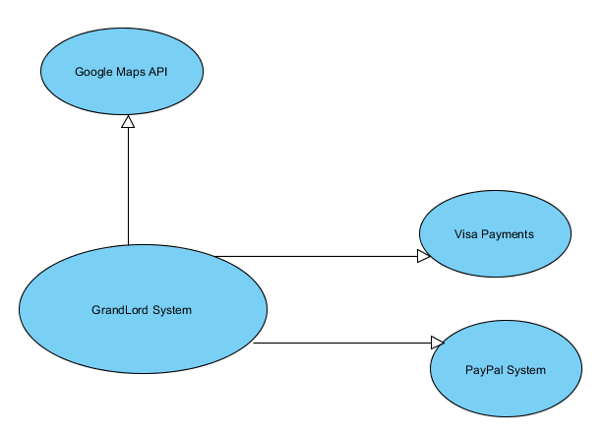

**6b. Business Events**

|  |  |  |
| --- | --- | --- |
| Event Name | Input from adjacent systems | Output to adjacent systems |
| Tenant moves out | Tenant scores their tenancy | Score appears on the property |
| Landlord verifies apartment | Landlord rates tenants and the property state | Rating appears on the tenants account and property |
| System produces weekly reports | Activity logs collected from the database | Usage report generated and sent to management |
| Monitoring tool checks the status of the website | Ping request sent to the website with no reply | Email alert generated to the sys admin |
| Database running out of space | New entries added to the system | Email alert generated and send to the db admin |
| Third party company subscribes to the GrandLord feeds | Registration form received | GrandLord feeds published on the third party company |
| User of Daft.ie looks up property online | Entry triggered in the GrandLord database | User sees GrandLord rating |
| Renting decreases due to increased property sales and vice versa | GrandLord website usage changes | Activity logs changes |

# 7. Business Data Model

**7a. Data Model**

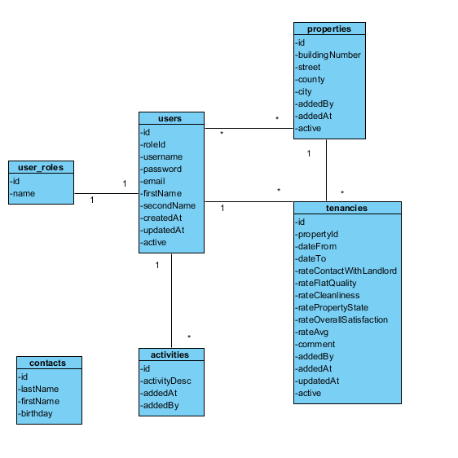

# 8. The Scope of the Product

**8a. Product Boundary**

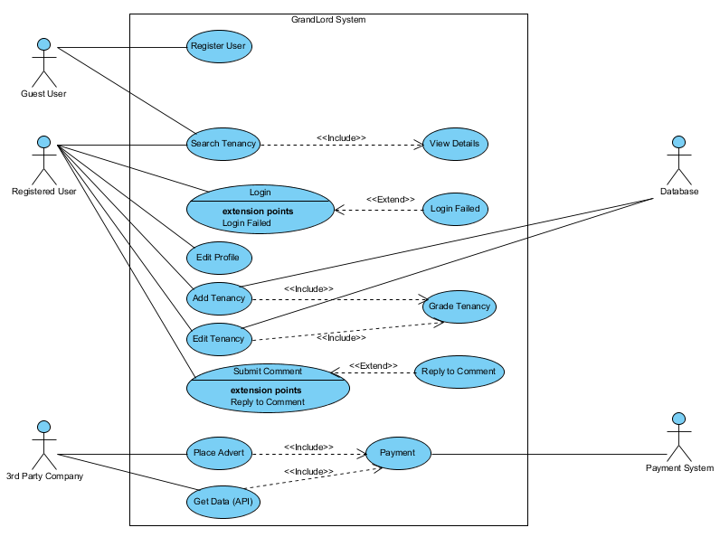

**8b. Individual Product Use Cases (8 sample use cases)**

|  |  |
| --- | --- |
| **Use Case** |  |
| Title | Register User |
| Description | User wants to create account on GrandLord website |
| Actors | User, GrandLord service |
| Pre-conditions | User is not registered/logged in |
| Post-conditions | User becomes a registered user |
| Success Scenario | 1. User types a user name of his choice 2. User select category of membership 3. User types a password 4. User retypes the password 5. System checks if the user names is not already in use 6. System checks if the two passwords are identical 7. System register new member with the given parameter (user name, password, type) |
| Exceptional Flow Of Events | 2a. User can choose one of the following options   1. Tenant 2. Landlord   4a. User name is already in use   1. User is requested to use another user name and password   5a. The two passwords are different   1. User is requested to retype (twice)his/her password |

|  |  |
| --- | --- |
| **Use Case** |  |
| Title | Login User |
| Description | User wants to log in using his account details |
| Actors | User, GrandLord website |
| Pre-conditions | User is not yet logged in |
| Post-conditions | User can access the system that that allows him to submit posts |
| Success Scenario | 1. User types his/her user name 2. User types his/her password 3. System checks if the given login parameters are correct 4. System welcomes user displaying his main page |
| Exceptional Flow Of Events | 3a. User provides invalid login parameters   1. See Login Failed |

|  |  |
| --- | --- |
| **Use Case** |  |
| Title | Login Failed |
| Description | User attempts to login and enters invalid login parameters |
| Actors | User, GrandLord website |
| Pre-conditions | User provides invalid login parameters |
| Post-conditions | User is informed about unsuccessful login |
| Success Scenario | 1. System redirects user to the Login Page 2. System informs the user that he typed invalid username/or password |
| Exceptional Flow Of Events | n/a |

|  |  |
| --- | --- |
| **Use Case** |  |
| Title | Search Tenancy |
| Description | User searches for tenancy based on given address |
| Actors | User, GrandLord website |
| Pre-conditions | User has opened main website page |
| Post-conditions | System displays found record on the website |
| Success Scenario | 1. User enters house number in the form 2. User enters street in the form 3. User enters city in the form 4. User enters county in the form 5. System search database for given criteria 6. System displays tenancy grading and comments |
| Exceptional Flow Of Events | 5a. Tenancy not found   1. System informs the user that property is not found 2. System redirects the user to Find tenancy page |

|  |  |
| --- | --- |
| **Use Case** |  |
| Title | Add Tenancy |
| Description |  |
| Actors | Registered Tenant or Landlord, GranLord website |
| Pre-conditions | User is already logged in |
| Post-conditions | Tenancy record saved |
| Success Scenario | 1. Registered user click add Tenancy button 2. User completes New Tenancy form (includes grading, see Grade Tenancy case) 3. System validates the form 4. System checks if tenancy is already in use 5. System adds the tenancy into Database 6. System displays entered information |
| Exceptional Flow Of Events | 3a. Validation fails   1. Error message displayed to the user to complete mandatory fields or remove unsupported characters   4a. Tenancy already exists in the system   1. Tenancy input is getting focused and message is displayed |

|  |  |
| --- | --- |
| **Use Case** |  |
| Title | Edit/Update Tenancy |
| Description |  |
| Actors | Registered Tenant or Landlord, GrandLord website |
| Pre-conditions | User is already logged in and found tenancy is displayed on the screen |
| Post-conditions | Tenancy record saved |
| Success Scenario | 1. Registered user click on edit tenancy button 2. Tenancy form gets populated with current values 3. User makes changes to the form (updates fields and grading) 4. System validates form 5. System updates the tenancy in the database 6. System displays entered information and confirmation message |
| Exceptional Flow Of Events | 4a. Validation fails   1. Error message displayed to the user to complete mandatory fields or remove unsupported characters |

|  |  |
| --- | --- |
| **Use Case** |  |
| Title | Grade Tenancy |
| Description | User grades Tenancy |
| Actors | Registered Tenant or Landlord, GranLord website |
| Pre-conditions | User sees add/edit Tenancy form |
| Post-conditions | Tenancy graded, form fields updated |
| Success Scenario | 1. User grades 5 separate tenancy categories with 1 to 10 scale |
| Exceptional Flow Of Events | n/a |

|  |  |
| --- | --- |
| **Use Case** |  |
| Title | Place advert |
| Description | 3rd Party Company place advert on website |
| Actors | 3rd Party Company, Payment System, GrandLord website |
| Pre-conditions | n/a |
| Post-conditions | Advertisement is placed on the GrandLord site |
| Success Scenario | 1. Third party company (any user) clicks on Submit Advert Requests button 2. Advert request form is displayed on the screen 3. User fills out the form 4. User clicks on submit 5. User sees a confirmation page where his request details are shown (containing a unique request id) 6. User is redirected to Payment page 7. Payment is completed and accepted 8. Request is saved 9. Email is sent to GrandLord admins and to third party company email, email contains invoice |
| Exceptional Flow Of Events | 4a. Validation fails   1. Error message displayed to the user to complete mandatory fields or remove unsupported characters   7a Payment refused   1. Error message displayed to the user …….. |

# 9. Functional and Data Requirements

***9a. Functional Requirements***

* *Allow user to register new account*
* *Allow to choose type of membership (account type – landlord/tenant/admin)*
* *Prompt user for username and password in order to get access to all functionality of the website*
* *Determine if user entered valid name and password*
* *Inform user if login / registration failed*
* *Inform user if login / registration successful*
* *Store user information in the database*
* *Allow registered user to display profile information*
* *Allow registered user to edit profile details*
* *Allow registered user to add new tenancy*
* *Present user a pre-defined form in order to add / update/ grade tenancy*
* *Validate user input (form)*
* *Store tenancy information in the database*
* *Allow user to search for tenancy information based on given criteria (address)*
* *Allow registered user to update existing and owned tenancy grading*
* *Allow any user to send inquiry form via Contact Us page*
* *Display information about the website via About page.*

# 10. Look and Feel Requirements

***10a. Appearance Requirements***

* *GrandLord website shall be correctly displayed on mobile devices*
* *Application shall use modern design standards*

# 11. Usability Requirements

**11a. Ease of Use Requirements**

* The product shall make the users want to use it
* The product shall be used by people with no training

**11b. Personalization and Internationalization Requirements**

* The product shall allow the user to work with English language

# 12. Performance Requirements

**12a. Reliability and Availability Requirements**

* The product shall be available for use 24 hours per day, 365 days per year

# 13. Operational and Environmental Requirements

**13a. Requirements for Interfacing**

* The product shall be platform independent
* The product shall work on last releases of five popular browsers (IE, Firefox, Safari, Opera, Chrome)
* The product shall support portable devices (Smartphones, Tablets)

# 14. Security Requirements

**14a. Privacy Requirements**

* The product shall protect private information in accordance with the relevant privacy laws and the organization’s information policy

# 15. Legal Requirements

15a. Compliance Requirements

* Personal information shall be implemented so as to comply with the Data Protection Act